Name: Rahul sharma
Assignment Name: Power BI Visual
Email:Edgerahul783@gmail.com

Question1:CreateaCardVisualtoshowTotalSales.

- Drag Card visua ontothereportcanvas.
- FromtheFieldspane→dragSalesfieldintothecard's"Fields"well.
- ItautomaticallyshowsSumofSales(that'sTotalSales).
- Format→Datalabel→turnon"Displayunits"→Millions(iftotalislarge, like
~$12–$22Mdependingondatasetversion)+Currencysymbol($).
- Addtitle:"TotalSales".
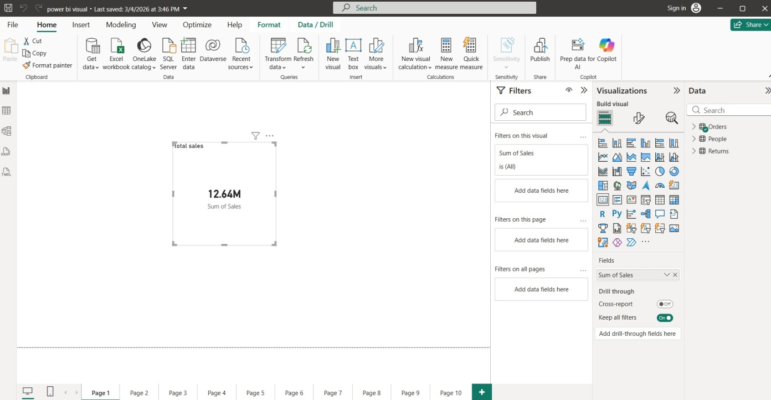

Question2:CreateaDonutChartshowingTotalSalesbyShipModeandwhichship mode generates the highest sales?
- DragaDonutchartvisual.
- Axis(Legend)→ShipMode(orShipModefield)
- Values→Sales(Sum)
- ThisshowssalesdistributionbyStandardClass,SecondClass,FirstClass,Same Day.

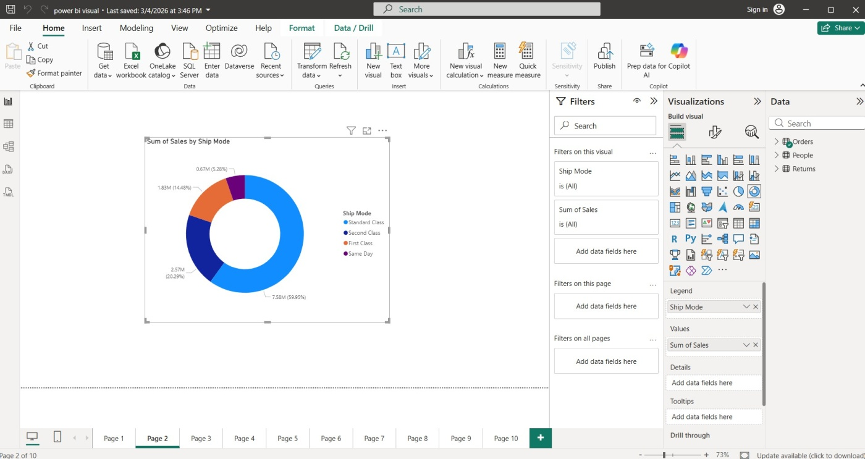

Question3:CreateaLineChartshowingtheSalesTrendovertime(byMonthand Year). Is there any noticeable seasonal pattern in sales?
- DragaLinechartvisual.
- Axis→OrderDate(makesureit'sDatehierarchy→dragMonthoruseHierarchyif available)
  - Or:Createnewcolumn/useOrderDate→Month-Yearformat(betterto create calculated column: Month Year = FORMAT([Order Date],
"mmm-yyyy"))
- Values→Sales(Sum)
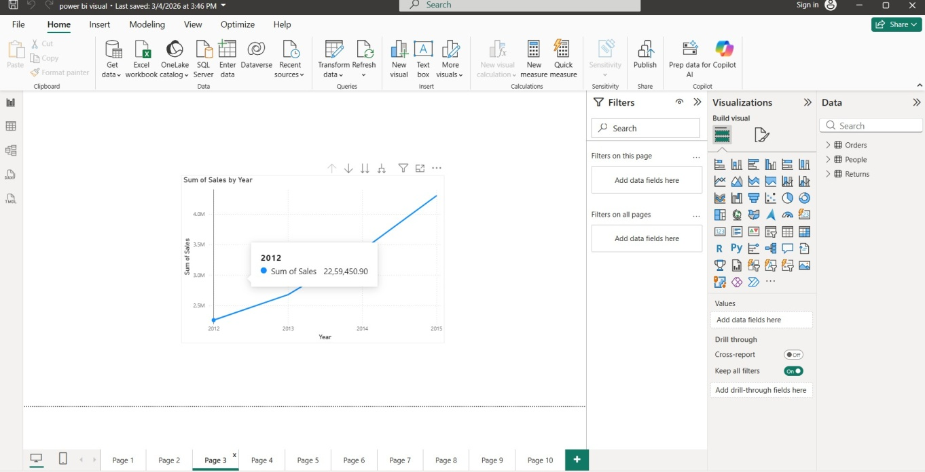

Question4:CreateaBarCharttocompareSalesbyCategory.

- DragaClusteredbarchart(orColumnchart).
- Axis→Category(orCategoryfield)
- Values→Sales(Sum)
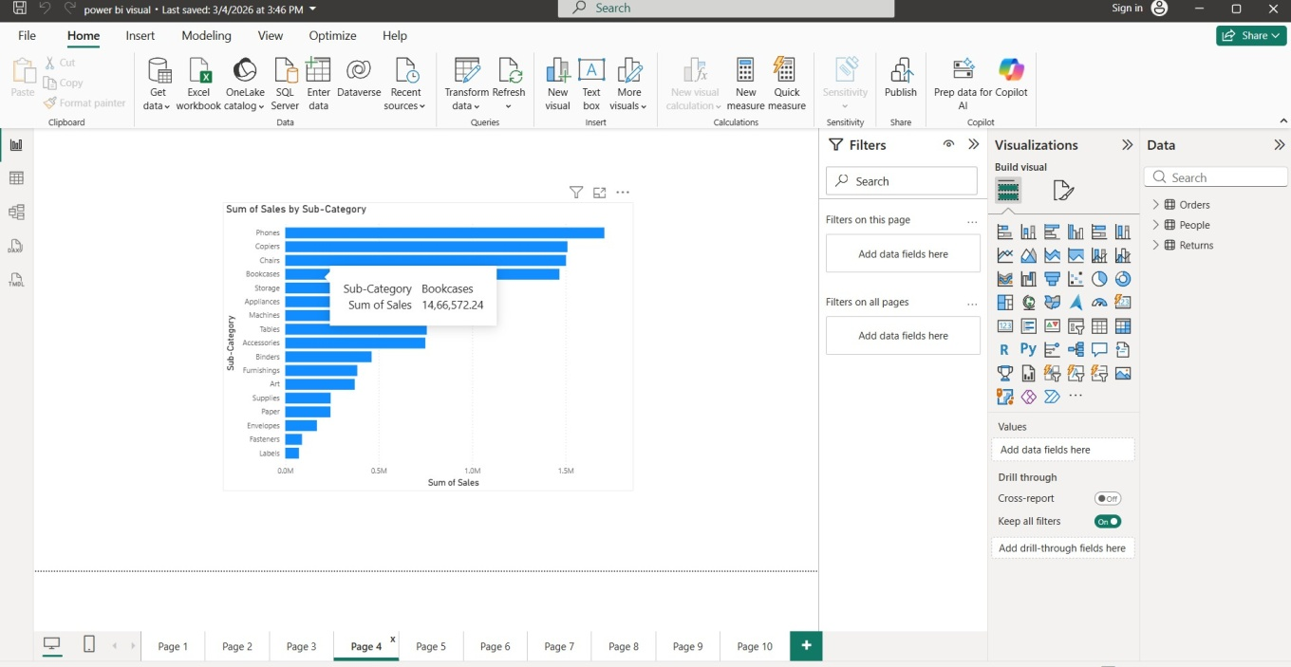

Question5:CreateaMatrixVisualtodisplaySalesbyMonthandCategoryand identify the month with the highest sales.
- DragaMatrixvisual.
- Rows→Category(orSub-Categoryifneeded)
- Columns→OrderDate(hierarchy→MonthorcreateMonth-Yearcolumn)
- Values→Sales(Sum)

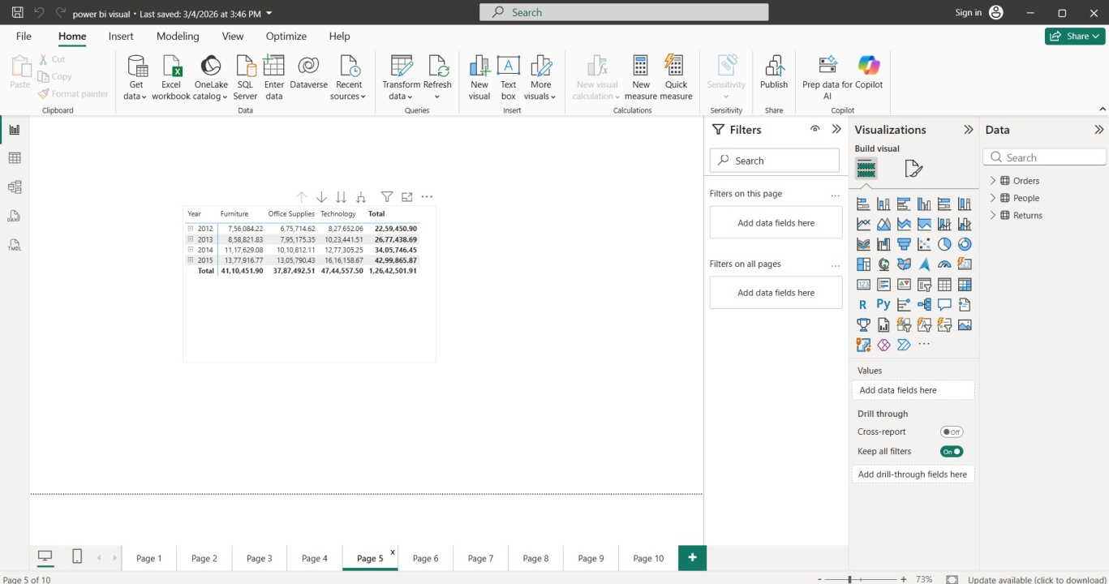

Question6:CreateaDecompositionTreeforSalesBreakdown.

- DragDecompositionTreevisual(availableinPowerBIvisualspane).
- Analyze→Sales(ordragSalesto"Analyze")
- Adddrilllevels(youcanaddmultiplefieldsinorder): Example order:
- Category
- Sub-Category
- ShipModeorRegionorMarket
- CustomerSegment
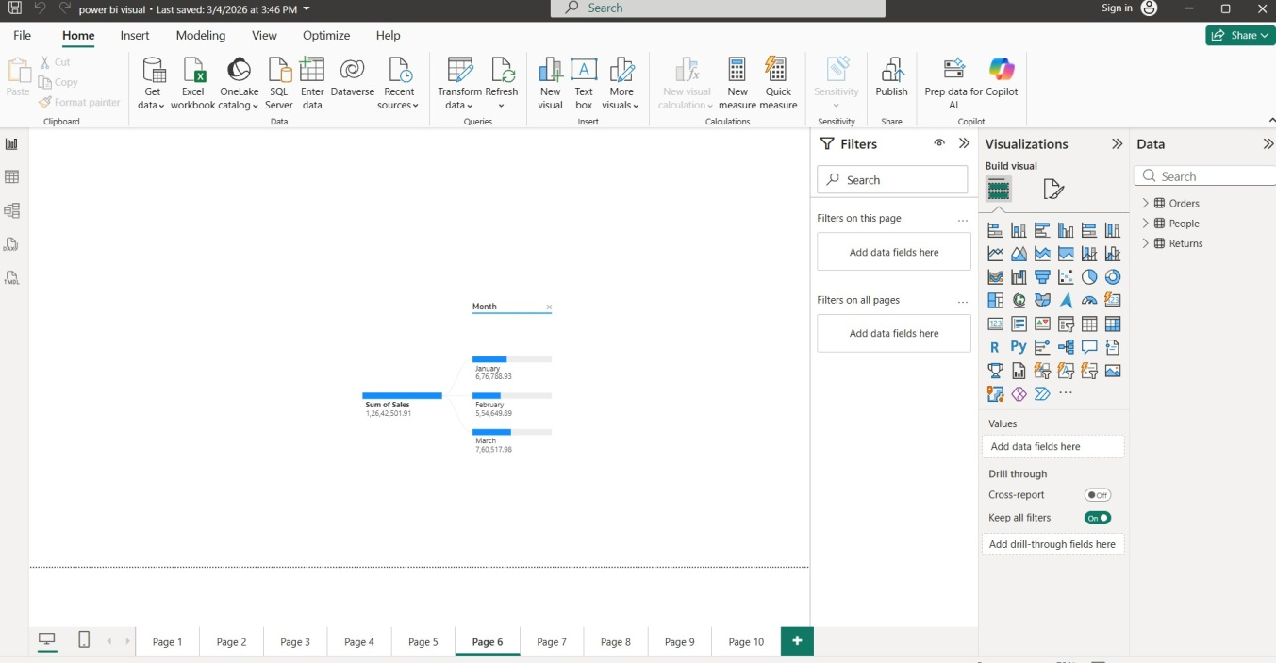

Question7:CreateaScatterCharttocompareDiscountvs.ProfitbySub-Category. Are there any outliers where high discounts resulted in negative profit?
- DragaScatterchart.
- XAxis→Discount(AverageorSum—usuallyAverageDiscount %)
- YAxis→Profit(SumorAverage)
- Legend/Details→Sub-Category(orCategory)
- Size→SalesorQuantity
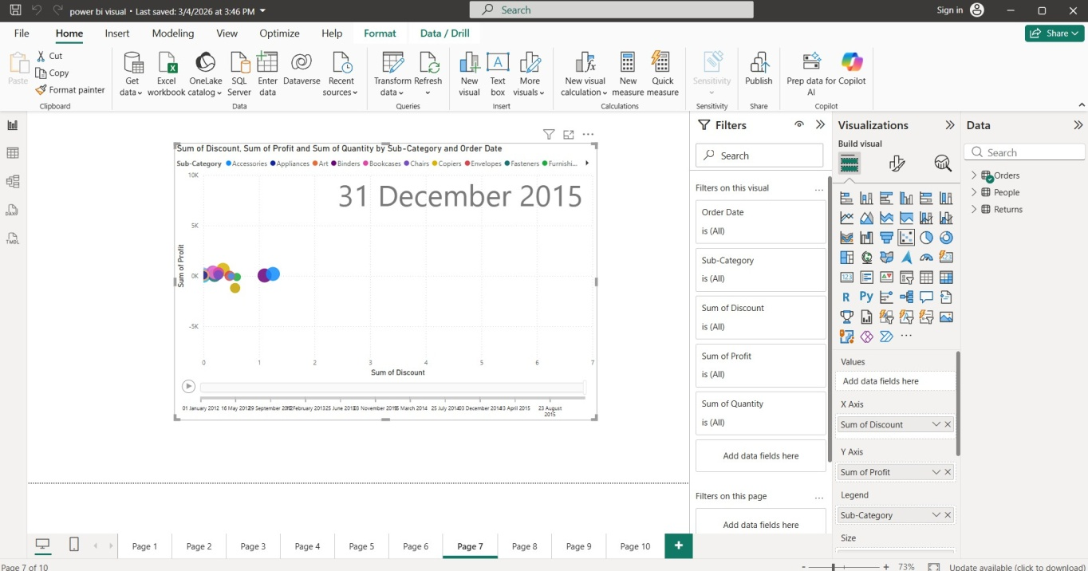

Question8:UseaFunnelCharttoshowthenumberofordersbyCustomerSegment.

- Visual→FunnelChart
- Axis(orCategory)→Segment(Consumer,Corporate,HomeOffice)
- Values→OrderID

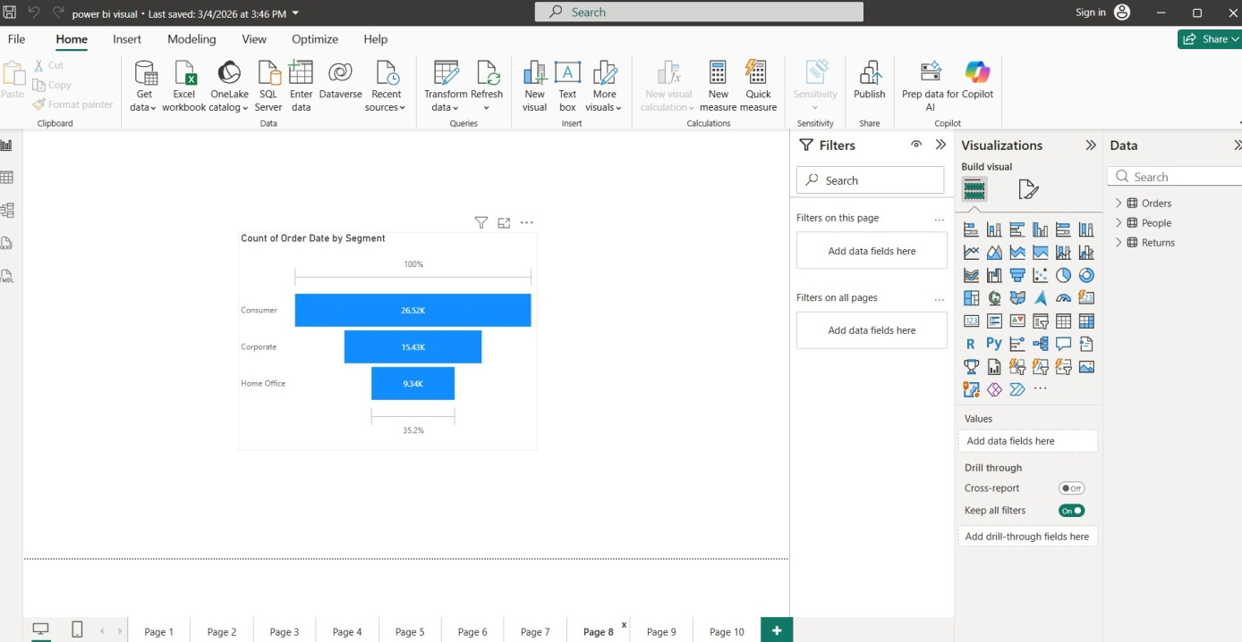

Question9:UseaWaterfallCharttoanalyzehowProfitchangesbyCategorywithin the countries.
- Visual→WaterfallChart
- Category→Category(orfirstputCountry/MarketinCategoryfordrill-down,then add Category in Breakdown)
- Values→Profit(Sum)
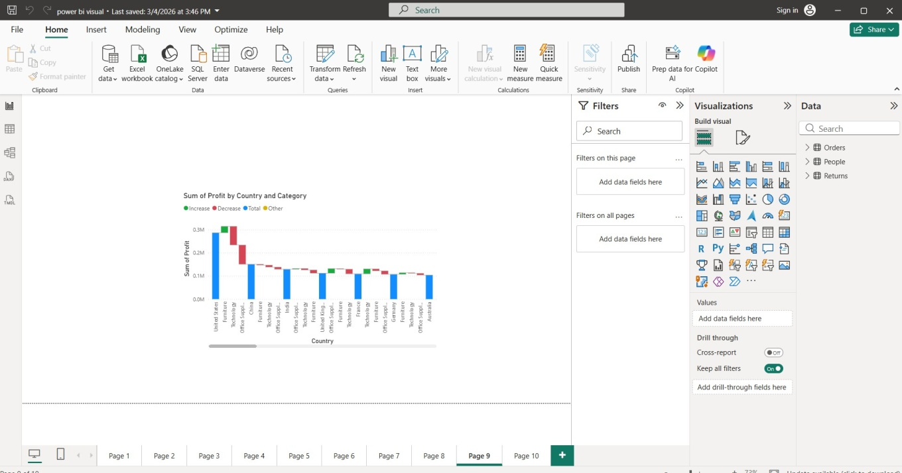

Question10:CreateaDual-AxisLineCharttoshowTotalSalesandProfitOverTime (by Month).
- Visual→LineandClusteredColumnChart(orLineChart→turnonsecondaryaxis)
- Axis(shared)→OrderDate→Hierarchy→Month(orcreateYear-Monthfield)
- ColumnValues→Sales(Sum)
- LineValues→Profit(Sum)
- InFormat→Y-Axis→turnonSecondaryY-axisforProfit
